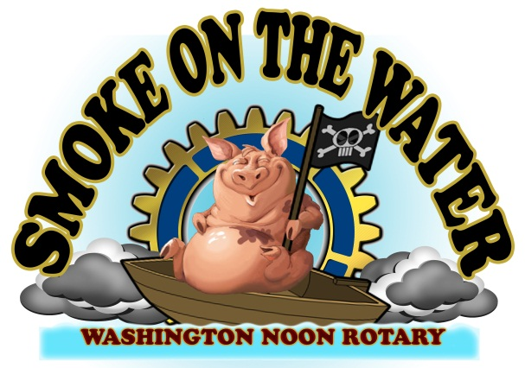

Smoke on the Water BBQ Cook Off---2021 Vendor Application
October 16, 2021
Business Name:________________________________________________________________________________
Contact Person(s):______________________________________________________________________________
Mailing Address: _______________________________________________________________________________
City:________________________________________ State: _____________ Zip Code: _____________________
Phone: ____________________ Fax: ___________________E-Mail Address: ______________________________
List All Items To Be Sold: _________________________________________________________________________
No meat items or SOTW themed t-shirts will be allowed. No silly string, pop rocks, toy guns/knives may be sold. Please attach photos of merchandise with application. The SOTW Committee reserves the right to remove any work that differs OR that does not fit the BBQ atmosphere.

ENTRY DEADLINE IS 5 p.m. OCT. 4, 2021 or until spaces are filled by receipt of paid applications.

Type of Vendor: Arts & Crafts ( ) Food ( ) Commercial ( ) Non-Profit ( )
____# of 10 x 20 food trailer, tent or canteen vendor spaces - $200 (*see note)
____# of 10 x 20 Handmade Arts/Crafts spaces - $150
____# of 10 x 10 Handmade Arts/Crafts spaces - $100
____# of 10 x 10 Commercial - $100 ____ 10 x 20 Commercial - $150
____# of 10 x 10 Non-Profit spaces - $75

Electrical: Yes ____

Check amount enclosed $________ (make checks payable to Washington Noon Rotary/SOTW)

*NOTE:
- Food vendors fall under new “Fire Department Regulations”, no cooking under tents and have a Fire Extinguisher on site. No meat items allowed. For more information call Pam Anderson 252-944-6136 or email at pamsue.anderson@gmail.com
- No t-shirt sales allowed unless approved by the SOTW Committee in advance.

Vendors will not hold the Cook Off participants, directors, volunteers, or employees responsible for claims, losses, fees, damages, or expense. The BBQ Cook Off Committee will not refund due to inclement weather, government action, strikes, or other matters beyond its control. By signing your name below you are stating that you have read the Vendor Application and accompanying information and you and your organization will abide by the rules or risk being removed from the Cook Off.

Signature: ______________________________________ Date: _____________________________________

Phone Number (252) 944-6136.
Smoke on the Water - c/o Washington Noon Rotary
P. O. Box 4- Washington, NC 27889

