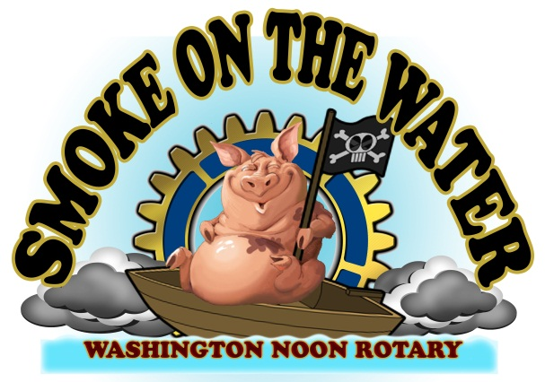

Smoke on the Water BBQ Cook Off---2021 Cooker Application for October 15th & 16th, 2021
(Entry Deadline is Monday, October 4th, 2021 or until available space is filled. First received, first accepted.

Team or Business Name:________________________________________________________________________________
Chief Cook:______________________________________________________________________________
Mailing Address: _______________________________________________________________________________
City:________________________________________ State: _____________ Zip Code: _____________________
Phone: ____________________ Fax: ___________________E-Mail Address: ______________________________
Showmanship Participant?: Y___ N___ Sponsor Name __________________________________________
Cooking with: Wood_____ Charcoal_____ Gas_____
Do you need electricity? Y____ N____ Do you have a tent? Y_____ N_____ What size?___________
Due to increased participation, parking is limited to one parking space per team. NO RV’s that do not fit into a regular parking space.
Please contact Pam Anderson at 252-944-6136 or pamsue.anderson@gmail.com for further information.
Entry fee is $175
Make checks payable to: Washington Noon Rotary/SOTW and mail to : Smoke on the Water, PO Box 86, Washington, NC 27889

A CHIEF COOKS MEETING WILL TAKE PLACE AT 5 P.M. ON FRIDAY, OCTOBER 15th AT THE SOTW INFORMATION RV.
SHOWMANSHIP JUDGING WILL TAKE PLACE AT 7:00 P.M. ON FRIDAY, OCTOBER 15th. Whole Hog Judging begins at 8 a.m. on Saturday, Oct. 16th.

Vendors will not hold the Cook Off participants, directors, volunteers, or employees responsible for claims, losses, fees, damages, or expense. The BBQ Cook Off Committee will not refund due to inclement weather, government action, strikes, or other matters beyond its control. By signing your name below you are stating that you have read the application and rules and that you and your organization will abide by the rules or risk being removed from the Cook Off. There will be no refunds unless non-acceptance into the Cook Off.

Signature: ______________________________________ Date: _____________________________________
Mail to: Washington Noon Rotary/SOTW, PO Box 86, Washington, NC 27889 Phone Number (252) 944-6136.
Smoke on the Water - c/o Washington Noon Rotary
P. O. Box 4- Washington, NC 27889
ENTRY DEADLINE IS MONDAY, OCT. 4th. ENTRIES WILL BE ACCEPTED ON A FIRST COME, FIRST SERVE BASIS. PLEASE SIGN UP AS SOON AS POSSIBLE TO GUARANTEE YOUR SPACE.

