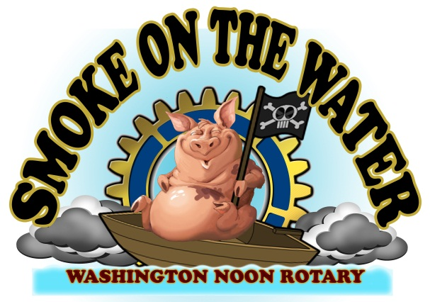

The 24th Annual Smoke on the Water festival and barbecue cook-off is scheduled for October 15th and 16th in downtown Washington and on the beautiful Washington waterfront. Two BBQ Competitions, a Chili Cook-off, a 5K Race, Car and Truck Show and Blues and Jazz Festival are just a few of the events to be featured.
The Washington Noon Rotary Club is proud to announce its coordination and annual presentation of the Smoke on the Water festival to benefit a wide variety of local community initiatives. All proceeds are given back to area non-profit groups like the Beaufort County Red Cross, the Boy’s & Girl’s Club, Cancer Center, Ruth’s House, ROTC, P.A.L., Eagles Wings, and the Blind Center to name a few.
The Washington Noon Rotary seeks to increase local awareness and participation, as well as contributing to the growth in tourism, sponsoring an event that positively impacts the local economy. We encourage you to get behind Smoke on the Water 2021 with your support which is needed more than ever this year.
Smoke on the Water Sponsorship
High on the Hog - $5,000 High on the Hog Sponsors will be included in television, radio, print ads and sponsor banners. They will also be on the cover the newspaper insert and receive free vendor space upon request.
Smokin’ Pig Sponsor - $1,000 Smokin’ Pig Sponsors will be included in television, print ads and sponsor banners. They will be listed in the SOTW newspaper tab. Vendor space is available upon request.
Patron of the Pig Sponsor - $500 Patron Sponsors will be included in the SOTW newspaper tab and on a sponsor banner.
Smoke on the Water Supporter - $150 Supporters will have their logo displayed on a sponsor banner.

Sponsor Name:_________________________________________________________________________________________

Sponsor Level:__________________________________________________________________________________________

Make checks payable to Washington Noon Rotary – SOTW and remit to:
Smoke on the Water - c/o Washington Noon Rotary
P. O. Box 4 - Washington, NC 27889

