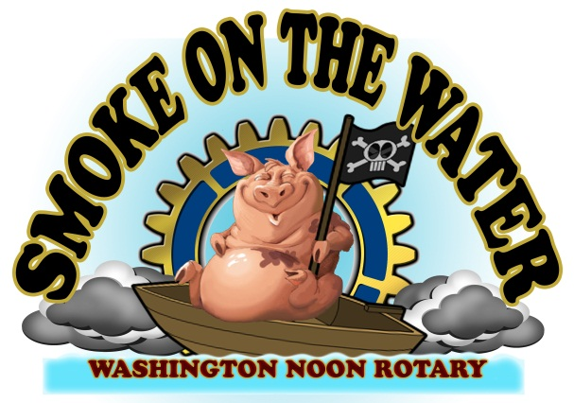

Smoke on the Water sponsor:
Smoke on the Water - c/o Washington Noon Rotary
P. O. Box 4 - Washington, NC 27889

The Washington Noon Rotary would like you to take part in our 24th annual Smoke on the Water BBQ Festival which is one of our annual signature fundraisers. This year’s festival will be held on Saturday, October 16th, 2021. All money raised from the festival is returned to the community in the way of donations to local charities such as the American Red Cross, Toys for Tots, Ruth’s House, Eagles Wings, the Zion Shelter , the Cancer Center and the Senior Center to name a few.
We could not make this happen without your financial support, so thank you for your sponsorship.
Smoke on the Water has become one of Eastern North Carolina’s favorite festivals featuring a BBQ and Chili competition, a Classic Car Show, a fire engine pull, a 5K Race, children’s entertainment and great live music, which will all contribute to the continued success of the festival. Again this year we will be hosting the State Championship for Traditional whole hog cooking as well as our Backyard Cooking Competition.
A sponsor form is included for your convenience. Please take a moment to look over the advertising sponsorship opportunities for this year’s Smoke on the Water.
If you have questions, concerns or suggestions in making this year’s Smoke on the Water festival an even better event, don’t hesitate to give us a call.
If you or your staff would like to serve as volunteers, please contact Pam Anderson at 252-944-6136.
Thank you again for your support! We sincerely value your contribution.

Sincerely,
Pam Anderson - Chair
Washington Noon Rotary’s Smoke on the Water Festival
252-944-6136

