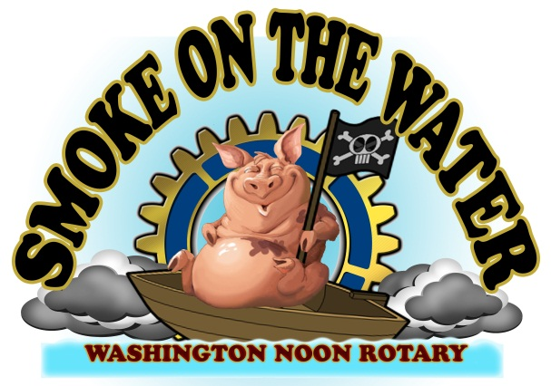

OFFICIAL RULES AND REGULATIONS
(A copy of these rules and a sample score sheet will be mailed to entrants prior to the contest)

1. The Chief Cook will be responsible for the conduct of his or her team/guests. A chief cooks meeting will be held at 5 p.m. on Friday, October 15th, at the SOTW Information RV. Showmanship Judging will take place at 7:00 p.m. Pigs distribution will begin at 8:00 p.m.

2. The Committee reserves the right to accept/reject any participant and will limit the number of contestants based upon space available.

3. All cooking spaces will be numbered and measure approximately 15 feet x 20 feet. Team sites will be pre-assigned and final. Any Chief Cook who desires to be next to another team should make requests accordingly at registration or note the request on their application. The staff will do its best to fulfill all requests but placement is not guaranteed.

4. All pigs will be cooked in an “above-the-ground” cooker. Pigs will be delivered beginning at 8:00 PM. Cooks may begin cooking any time after receiving their pigs.

5. Open fires will be allowed only for traditional cookers. Please keep these fires as low as possible and protect the unwary from stumbling into them. Each contestant is responsible for removing ash with them when the leave the site. DO NOT DUMP ASHES IN THE PARKING LOTS.

6. Each cooker should meet safety standards such as proper regulator, secure tanks, or any other requirements the Committee deems necessary. Fire Extinguishers are required on all cook sites.

7. This rule should be heeded by all gas cookers:
a. If burner goes out, immediately shut off the gas.
b. Open all doors and lids on cooker.
c. Wait 2 minutes before attempting to relight. Leave lid open while relighting.

8. Each chief cook must have the following utensils on hand for judging:
a. Four sharp knives.
b. Four cups of water.
c. Towels, paper or cloth.
d. Small containers for your sauce.

9. A representative of the Committee will be named:
a. To accompany judges while the pigs are being judged and take score sheets.
b. To know exclusively, as relates to judges, who will present the pig for judging.
c. To ensure only 1 representative of cooking site is present when pig is judged.

10. No one person will present more than one pig for judging per contest.

11. If a chief cook decides to withdraw from competition, he/she will notify the Committee as soon as possible. No refunds will be made if canceling after the deadline. Anyone canceling after the deadline should try and find a replacement cook their pig.

12. All pigs must be turned in whole to the pick-up committee. The pick-up committee will remove the ribs for the cook/sponsors. Any pig will be disqualified if any part of the pig is removed or intentionally disturbed. No pig will be removed from the pig cooking site under any circumstances.

13. Any pigs judged “Not Done” will be disqualified. Cooks are required to continue cooking until, in the opinion of the Committee, the pig is done.

14. Each judge will be given score sheets with no information identifying the cook/sponsor. SOTW Accountants (not judges) will total/grand total the score sheets.

15. Cookers’ Order of Judging: Cooks will be judged beginning at 8AM. A drawing will determine groups and judging order will be determined by assigned space. Cooks are not allowed a pass. Judges will complete the entire group in the determined order by assigned space.

16. In the event of ties, positions will be determined by highest meat taste score. In the event of a tie in showmanship, positions will be determined by luck of the draw.

17. Showmanship judging and tallying will take place Friday evening at 7:00PM.

18. Contest winners will be announced as soon as possible, following the judging and score tallying. A completed copy of the totaled scores will be available after the awards ceremony.

19. While we recognize that each contestant will be professional, contestants are expected to respect the rights of all other contestants with special emphasis on loud music, loud and/or profane language or infringement of adjoining sites with equipment, cookers, etc.

20. Contestants may not sell any food, drinks or other items to the public.

21. All visitors who are not members of the cooking team must exit the cooking contest area by midnight Friday evening. Only contest participants should be present from Midnight Friday until 8 AM Saturday.

22. Each contestant is requested to keep the walkway clear of obstructions. Due to increased participation please limit on site vehicles to one per cooking team. Please make preparations with other members to ride in together or meet on site. This also means that we will not have parking spaces available for large RV’s. All on site vehicles must fit into one parking space.

23. The Smoke on the Water Committee and Staff shall not be responsible or liable for the property of any team. All property of the teams shall be under the care, custody and control of the team, whether in transit to or from or within the cook-off site.

24. Violations of these rules and regulations may result in disqualification. Decisions of the Smoke on the Water Committee and judges are final. The Committee reserves the right to make additional rules as situations or events dictate.
Smoke on the Water - c/o Washington Noon Rotary
P. O. Box 4 - Washington, NC 27889
Smoke on the Water - c/o Washington Noon Rotary
P. O. Box 4 - Washington, NC 27889

